Mathematical Model

🌟 Definition
# Source: AI Source: Provided by: [Data Path: Persons Table -> ID Column: 1, Name_En Column: Motasem Essam] -> From: [ChatGPT] on [5/29/2026]
A mathematical model is a mathematical representation of a real-world system, process, or phenomenon using mathematical objects such as equations, functions, graphs, or algorithms.
It translates real-life problems into mathematical language so they can be analyzed and solved.

🎯 Purpose of a Mathematical Model
# Source: AI Source: Provided by: [Data Path: Persons Table -> ID Column: 1, Name_En Column: Motasem Essam] -> From: [ChatGPT] on [5/29/2026]
- To understand real-world systems
- To predict future behavior
- To simplify complex problems
- To test ideas and hypotheses
- To support decision-making in science, engineering, economics, and more

📚 Key Characteristics
# Source: AI Source: Provided by: [Data Path: Persons Table -> ID Column: 1, Name_En Column: Motasem Essam] -> From: [ChatGPT] on [5/29/2026]
A mathematical model is:
- Based on real-world situations
- Expressed using mathematical language
- Simplified (not every detail is included)
- Used for prediction and analysis
- Adjustable when new data appears

🧩 Components of a Mathematical Model
# Source: AI Source: Provided by: [Data Path: Persons Table -> ID Column: 1, Name_En Column: Motasem Essam] -> From: [ChatGPT] on [5/29/2026]
- Real-world system (what we study)
- Assumptions (simplifications)
- Mathematical representation (equations, graphs, formulas)
- Solution or analysis
- Interpretation of results

📖 Types of Mathematical Models

1. Deterministic Models
# Source: AI Source: Provided by: [Data Path: Persons Table -> ID Column: 1, Name_En Column: Motasem Essam] -> From: [ChatGPT] on [5/29/2026]
- No randomness
- Same input → same output
Example:
$$F=ma$$

2. Probabilistic (Stochastic) Models
# Source: AI Source: Provided by: [Data Path: Persons Table -> ID Column: 1, Name_En Column: Motasem Essam] -> From: [ChatGPT] on [5/29/2026]
- Include randomness or uncertainty
- Used in weather, finance, biology
Example:
- Probability of rain tomorrow

3. Static Models
# Source: AI Source: Provided by: [Data Path: Persons Table -> ID Column: 1, Name_En Column: Motasem Essam] -> From: [ChatGPT] on [5/29/2026]
- Do not change over time
- Describe a system at one moment
Example:
- Geometry of a bridge

4. Dynamic Models
# Source: AI Source: Provided by: [Data Path: Persons Table -> ID Column: 1, Name_En Column: Motasem Essam] -> From: [ChatGPT] on [5/29/2026]
- Change over time
- Used in population growth, motion, economics
Example:
$$\frac{dP}{dt}=rP$$

🧩 Examples of Mathematical Models

1. Population Growth Model
# Source: AI Source: Provided by: [Data Path: Persons Table -> ID Column: 1, Name_En Column: Motasem Essam] -> From: [ChatGPT] on [5/29/2026]
Describes how a population increases over time.
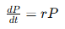
$$P(t)=P_{0}e^{rt}$$

2. Physics Model (Motion)
# Source: AI Source: Provided by: [Data Path: Persons Table -> ID Column: 1, Name_En Column: Motasem Essam] -> From: [ChatGPT] on [5/29/2026]
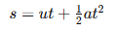
$$s=ut+\frac{1}{2}at^{2}$$

3. Economic Model
# Source: AI Source: Provided by: [Data Path: Persons Table -> ID Column: 1, Name_En Column: Motasem Essam] -> From: [ChatGPT] on [5/29/2026]
Used to describe supply and demand relationships.

4. Epidemic Model
# Source: AI Source: Provided by: [Data Path: Persons Table -> ID Column: 1, Name_En Column: Motasem Essam] -> From: [ChatGPT] on [5/29/2026]
Used to predict spread of diseases.

🔗 Relationship to Other Concepts
# Source: AI Source: Provided by: [Data Path: Persons Table -> ID Column: 1, Name_En Column: Motasem Essam] -> From: [ChatGPT] on [5/29/2026]
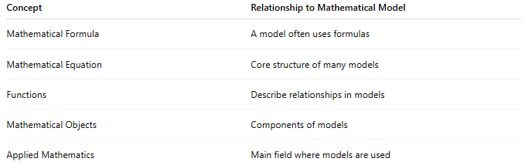
Concept | Relationship to Mathematical Model
Mathematical Formula | A model often uses formulas
Mathematical Equation | Core structure of many models
Functions | Describe relationships in models
Mathematical Objects | Components of models
Applied Mathematics | Main field where models are used

📖 Model vs Formula vs Theory
# Source: AI Source: Provided by: [Data Path: Persons Table -> ID Column: 1, Name_En Column: Motasem Essam] -> From: [ChatGPT] on [5/29/2026]
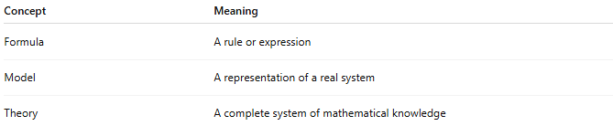
Concept | Meaning
Formula | A rule or expression
Model | A representation of a real system
Theory | A complete system of mathematical knowledge

🧠 Simple Analogy
# Source: AI Source: Provided by: [Data Path: Persons Table -> ID Column: 1, Name_En Column: Motasem Essam] -> From: [ChatGPT] on [5/29/2026]
A mathematical model is like a map:
- Real world = actual terrain
- Model = simplified map
- Purpose = understand and predict

🧭 Summary
# Source: AI Source: Provided by: [Data Path: Persons Table -> ID Column: 1, Name_En Column: Motasem Essam] -> From: [ChatGPT] on [5/29/2026]
A mathematical model is a mathematical description of a real-world situation using formulas, equations, and structures. It helps us understand, analyze, and predict how real systems behave.

